Project: Collect User Data Using AWS S3

1. Project Overview
Goal: Build a small web page with a form. The user types a Name and Surname and clicks Submit. The data is saved as a JSON file in AWS S3.
How it works :
- The user opens the website (hosted on S3).
- The user fills in the form and clicks Submit.
- The page asks Amazon Cognito for temporary credentials (like a short-lived pass).
- Using that pass, the page uploads a JSON file into the submissions/ folder in S3.
Why Cognito? We must never put AWS access keys in the code. Cognito gives safe, temporary keys instead.
Why esbuild? The AWS SDK is written for Node.js. esbuild packs the SDK and our code into one file (bundle.js) that a browser can run.

2. What You Need Before Starting
- An AWS account: https://ap-south-1.console.aws.amazon.com
- Node.js (LTS version) installed: https://nodejs.org/en/download. Check with node -v, npm -v
- A code editor (VS Code or Notepad): https://code.visualstudio.com/download.
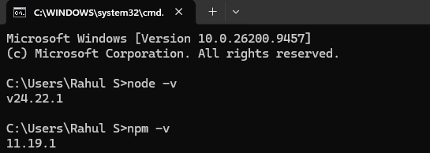

Values used in this guide (replace with your own):
Item | Example value
Bucket name | YOUR-BUCKET (must be globally unique)
Region | ap-south-1 (Mumbai)
Identity Pool ID | Copied in Step 7

3. Final Project Folder
s3-form-project/
├── index.html (you write it)
├── app.js (you write it)
├── bundle.js (generated, do not edit)
├── package.json
└── node_modules/

PART A: Set Up the Project on Your Computer

Step 1. Create the folder and install packages
Open a terminal and run:
mkdir s3-form-project
cd s3-form-project
npm init -y
npm install @aws-sdk/client-s3 @aws-sdk/credential-providers
npm install --save-dev esbuild

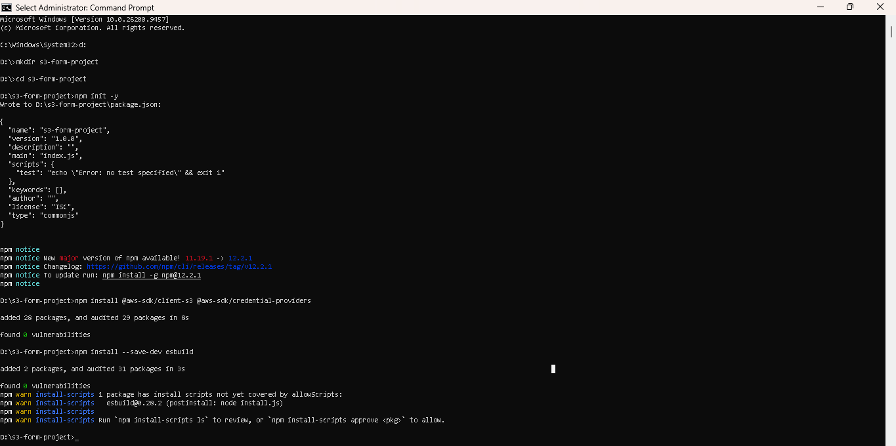

PART B: Set Up AWS
Do this before finishing app.js, because you need the Identity Pool ID.

Step 2. Create the S3 bucket
- Go to AWS Console → S3 → Create bucket.
- Enter the bucket name and choose your region.
- Under Block Public Access, untick only these all options:
- Keep the two ACL options ticked. Tick the acknowledgement box.
- Click Create bucket.

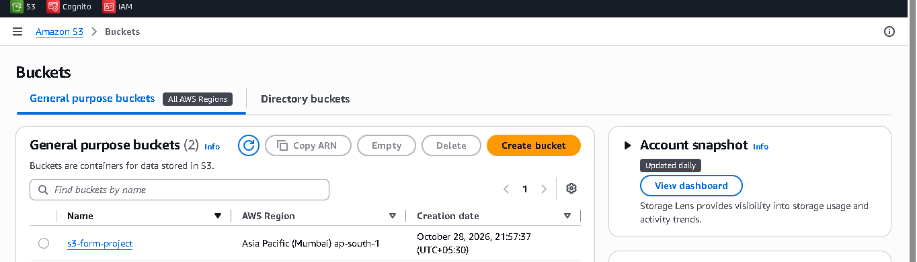

Step 3. Turn on static website hosting
- Open the bucket → Properties tab.
- Scroll to Static website hosting → Edit.
- Select Enable. Set Index document to index.html. Save.
- Copy the Bucket website endpoint shown at the bottom. This is your hosted website URL. It looks like: http://s3-form-project.s3-website.ap-south-1.amazonaws.com

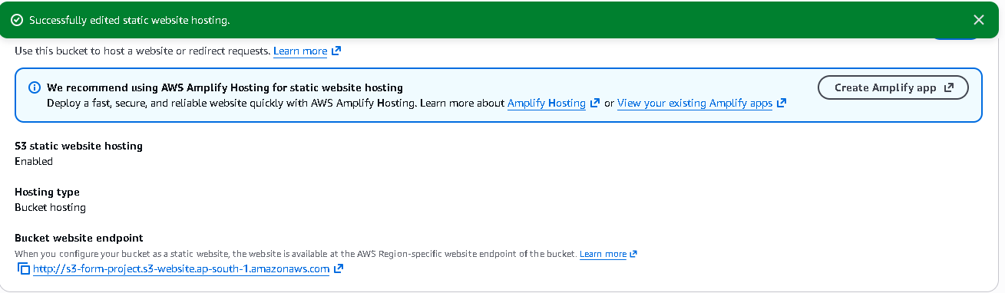

Step 4. Add the bucket policy (public read for site files only)
Bucket → Permissions → Bucket policy → Edit. Paste:
{
"Version": "2012-10-17",
"Statement": [
{
"Sid": "PublicReadSiteFilesOnly",
"Effect": "Allow",
"Principal": "*",
"Action": "s3:GetObject",
"Resource": [
"arn:aws:s3:::YOUR-BUCKET/index.html",
"arn:aws:s3:::YOUR-BUCKET/bundle.js"
]
}
]
}
Only the two site files are public. Files in submissions/ stay private.

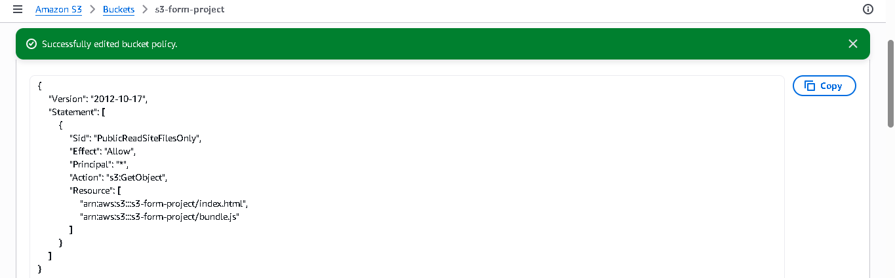

Step 5. Add the CORS rule
CORS lets the website upload to the bucket. Bucket → Permissions → Cross-origin resource sharing (CORS) → Edit. Paste:
[
{
"AllowedOrigins": ["http://YOUR-BUCKET.s3-website.ap-south-1.amazonaws.com"],
"AllowedMethods": ["PUT", "POST"],
"AllowedHeaders": ["*"],
"ExposeHeaders": ["ETag"],
"MaxAgeSeconds": 3000
}
]

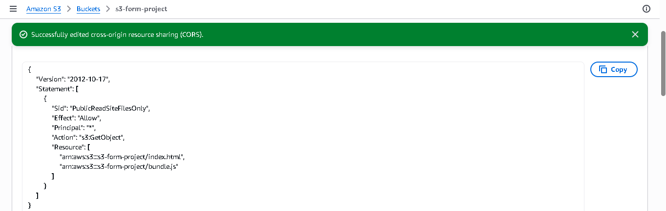

Step 6. Create the Cognito Identity Pool
- Go to Amazon Cognito → Identity pools → Create identity pool.
- Turn on Guest access.
- Let AWS create a new IAM role for guests. Name it Cognito_FormGuestRole.
- Name the pool form-identity-pool and create it.

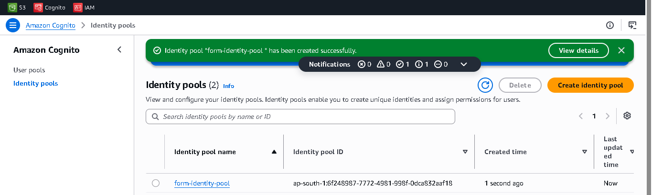

Step 7. Copy the Identity Pool ID
Open the pool and copy its ID. It looks like: ap-south-1:6f248987-7772-4981-998f-0dca832aaf18

Step 8. Give the guest role least-privilege permission
- Go to IAM → Roles → open Cognito_FormGuestRole.
- Remove any extra policies that were added automatically.
- Click Add permissions → Create inline policy → JSON. Paste:
{
"Version": "2012-10-17",
"Statement": [
{
"Effect": "Allow",
"Action": "s3:PutObject",
"Resource": "arn:aws:s3:::YOUR-BUCKET/submissions/*"
}
]
}
- Name it AllowSubmissionsUpload and save.
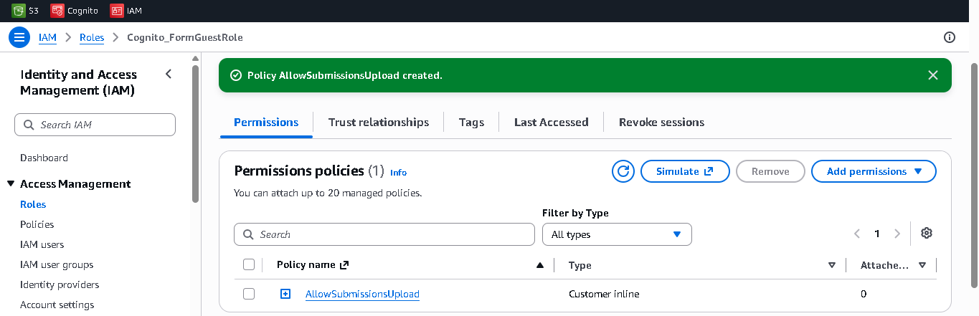
Result: guests can only write into submissions/. They cannot read, list, or delete anything.

PART C: Write the Code

Step 9. Create index.html
<!DOCTYPE html>
<html lang="en">
<head>
<meta charset="UTF-8">
<meta name="viewport" content="width=device-width, initial-scale=1">
<title>User Data Form</title>
<style>
:root {
--bg: #e9eef6;
--bg-accent: #cfdcf5;
--card: #ffffff;
--ink: #14213d;
--muted: #5b6b86;
--line: #d5dded;
--brand: #2447d6;
--brand-dark: #1a35a8;
--ok: #0f7a4d;
--ok-bg: #e3f6ec;
--err: #b42318;
--err-bg: #fdebe9;
--info-bg: #eaf0ff;
}
@media (prefers-color-scheme: dark) {
:root {
--bg: #0e1526;
--bg-accent: #1a2748;
--card: #162038;
--ink: #eef2fb;
--muted: #9fb0cf;
--line: #2a3a5e;
--brand: #6f8cff;
--brand-dark: #8da3ff;
--ok: #5fdc9f;
--ok-bg: #12301f;
--err: #ff8f84;
--err-bg: #3a1a18;
--info-bg: #1c2a4d;
}
}

* { box-sizing: border-box; }

html, body { height: 100%; }

body {
margin: 0;
font-family: "Segoe UI", system-ui, -apple-system, Roboto, Arial, sans-serif;
color: var(--ink);
background:
radial-gradient(900px 500px at 10% -10%, var(--bg-accent), transparent 60%),
var(--bg);
display: flex;
align-items: center;
justify-content: center;
padding: 24px;
}

.card {
width: 100%;
max-width: 440px;
background: var(--card);
border: 1px solid var(--line);
border-radius: 18px;
padding: 36px 32px 32px;
box-shadow: 0 18px 40px rgba(20, 33, 61, 0.12);
}

.icon {
width: 48px;
height: 48px;
border-radius: 14px;
background: var(--brand);
display: grid;
place-items: center;
margin-bottom: 20px;
}
.icon svg { width: 26px; height: 26px; stroke: #fff; }

h2 {
margin: 0 0 6px;
font-size: 1.6rem;
line-height: 1.2;
letter-spacing: -0.01em;
}

.sub {
margin: 0 0 26px;
color: var(--muted);
font-size: 0.95rem;
line-height: 1.5;
}

.field { margin-bottom: 18px; }

label {
display: block;
margin-bottom: 7px;
font-size: 0.9rem;
font-weight: 600;
}

input[type="text"] {
width: 100%;
padding: 13px 14px;
font-size: 1rem;
font-family: inherit;
color: var(--ink);
background: var(--card);
border: 1.5px solid var(--line);
border-radius: 10px;
transition: border-color 0.15s, box-shadow 0.15s;
}
input[type="text"]::placeholder { color: var(--muted); opacity: 0.7; }
input[type="text"]:hover { border-color: var(--muted); }
input[type="text"]:focus {
outline: none;
border-color: var(--brand);
box-shadow: 0 0 0 4px color-mix(in srgb, var(--brand) 22%, transparent);
}

button {
width: 100%;
margin-top: 6px;
padding: 14px 18px;
font-size: 1rem;
font-weight: 600;
font-family: inherit;
color: #fff;
background: var(--brand);
border: 0;
border-radius: 10px;
cursor: pointer;
transition: background 0.15s, transform 0.1s;
}
@media (prefers-color-scheme: dark) { button { color: #0e1526; } }
button:hover { background: var(--brand-dark); }
button:active { transform: translateY(1px); }
button:focus-visible {
outline: 3px solid var(--brand);
outline-offset: 3px;
}
button:disabled { opacity: 0.6; cursor: not-allowed; }

#status {
margin: 18px 0 0;
padding: 0;
font-size: 0.95rem;
font-weight: 500;
border-radius: 10px;
text-align: center;
}
#status:not(:empty) { padding: 12px 14px; background: var(--info-bg); }
#status.success { color: var(--ok); background: var(--ok-bg); }
#status.error { color: var(--err); background: var(--err-bg); }

.note {
margin: 22px 0 0;
text-align: center;
font-size: 0.8rem;
color: var(--muted);
}

@media (max-width: 480px) {
.card { padding: 28px 22px 24px; }
}
@media (prefers-reduced-motion: reduce) {
* { transition: none !important; }
}
</style>
</head>
<body>
<main class="card">
<div class="icon" aria-hidden="true">
<svg viewBox="0 0 24 24" fill="none" stroke-width="2" stroke-linecap="round" stroke-linejoin="round">
<path d="M20 21v-2a4 4 0 0 0-4-4H8a4 4 0 0 0-4 4v2"/>
<circle cx="12" cy="7" r="4"/>
</svg>
</div>

<h2>Enter your details</h2>
<p class="sub">Add your name and surname. Your details are saved securely.</p>

<form id="userForm">
<div class="field">
<label for="name">Name</label>
<input type="text" id="name" placeholder="e.g. Rahul" autocomplete="given-name" required>
</div>

<div class="field">
<label for="surname">Surname</label>
<input type="text" id="surname" placeholder="e.g. Sharma" autocomplete="family-name" required>
</div>

<button type="submit" id="submitBtn">Submit</button>
</form>

<p id="status" role="status" aria-live="polite"></p>
<p class="note">Stored privately in AWS S3</p>
</main>

<script src="bundle.js"></script>

<!-- Styles the status message and disables the button while uploading -->
<script>
(function () {
var status = document.getElementById("status");
var btn = document.getElementById("submitBtn");
new MutationObserver(function () {
var t = status.textContent || "";
status.className = t.indexOf("successfully") > -1 ? "success"
: t.indexOf("Error") === 0 ? "error" : "";
btn.disabled = t === "Uploading...";
}).observe(status, { childList: true, characterData: true, subtree: true });
})();
</script>
</body>
</html>

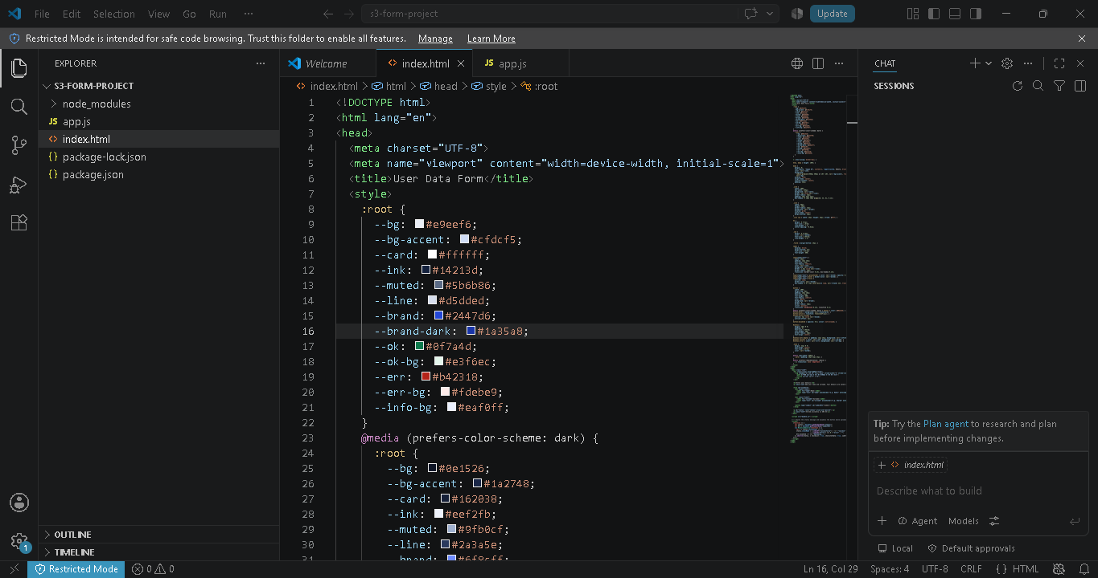
Index.html file

Step 10. Create app.js
Replace YOUR-BUCKET and the Pool ID with your own values.
import { S3Client, PutObjectCommand } from "@aws-sdk/client-s3";
import { fromCognitoIdentityPool } from "@aws-sdk/credential-providers";

// ---------------------------------------------------------------
// 1. SETTINGS (only change IDENTITY_POOL_ID)
// ---------------------------------------------------------------
const REGION = "ap-south-1";
const BUCKET = "s3-form-project";
const IDENTITY_POOL_ID = "ap-south-1:6f248987-7772-4981-998f-0dca832aaf18";
const UPLOAD_FOLDER = "submissions";

// ---------------------------------------------------------------
// 2. S3 CLIENT (uses temporary credentials from Amazon Cognito,
// so no access keys are stored in this file)
// ---------------------------------------------------------------
const s3 = new S3Client({
region: REGION,
credentials: fromCognitoIdentityPool({
clientConfig: { region: REGION },
identityPoolId: IDENTITY_POOL_ID,
}),
requestChecksumCalculation: "WHEN_REQUIRED",
});

// ---------------------------------------------------------------
// 3. HELPERS
// ---------------------------------------------------------------

// Unique file name, e.g. submissions/1730100000000-ab12cd34.json
// (crypto.randomUUID needs HTTPS, and the S3 website uses HTTP)
function makeFileName() {
const random = Math.random().toString(36).slice(2, 10);
return `${UPLOAD_FOLDER}/${Date.now()}-${random}.json`;
}

function showStatus(element, message) {
element.textContent = message;
}

// ---------------------------------------------------------------
// 4. FORM HANDLER
// ---------------------------------------------------------------
const form = document.getElementById("userForm");
const statusEl = document.getElementById("status");

form.addEventListener("submit", async (event) => {
event.preventDefault();

const name = document.getElementById("name").value.trim();
const surname = document.getElementById("surname").value.trim();

if (!name || !surname) {
showStatus(statusEl, "Error: Please enter both name and surname.");
return;
}

const data = {
name,
surname,
submittedAt: new Date().toISOString(),
};

try {
showStatus(statusEl, "Uploading...");

await s3.send(
new PutObjectCommand({
Bucket: BUCKET,
Key: makeFileName(),
Body: JSON.stringify(data, null, 2),
ContentType: "application/json",
})
);

showStatus(statusEl, "Submitted successfully!");
form.reset();
} catch (err) {
console.error("Upload failed:", err);
showStatus(statusEl, "Error: " + err.message);
}
});

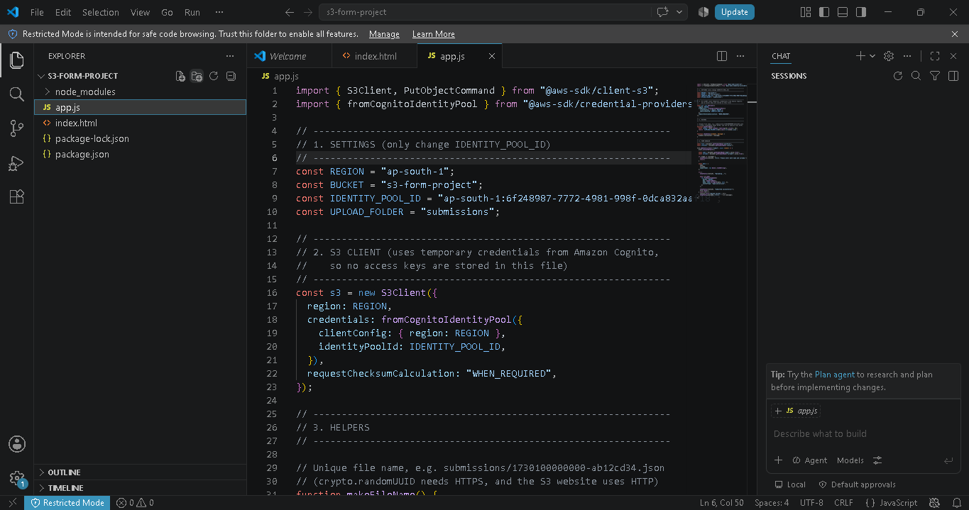
app.js File

Step 11. Generate bundle.js
In the terminal, inside the project folder:
npm install @aws-sdk/client-cognito-identity @aws-sdk/credential-provider-cognito-identity
npm ls @aws-sdk/client-cognito-identity @aws-sdk/credential-provider-cognito-identity
npx esbuild app.js --bundle --platform=browser --format=iife --outfile=bundle.js
Do not edit bundle.js by hand. Run this command again every time you change app.js.
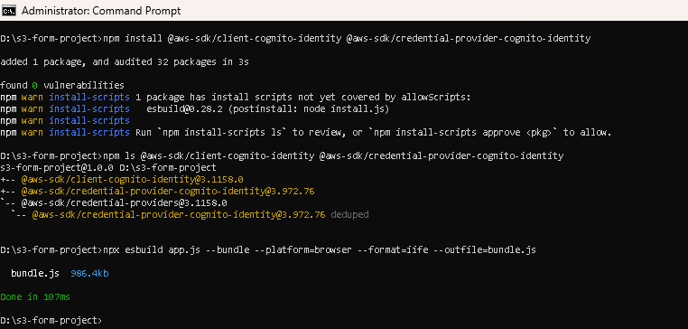
bundel.js

PART D: Deploy and Test

Step 12. Upload the files to S3
- Open your bucket → Objects → Upload.
- Add only index.html and bundle.js.
- Click Upload.
Do not upload app.js or node_modules.
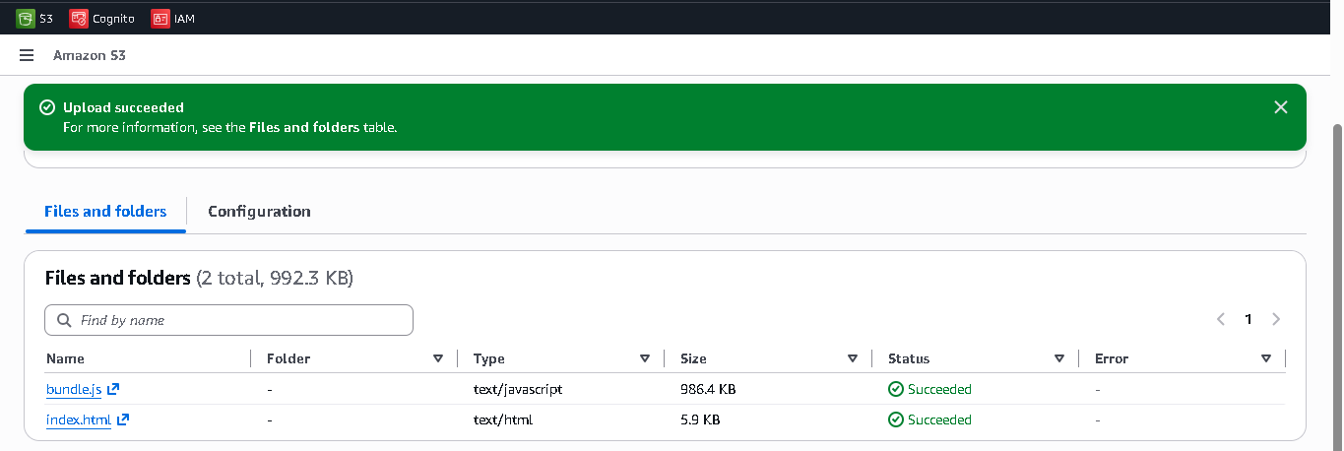

Step 13. Test the website
- Open your website endpoint URL in a browser.
- Type a name and surname. Click Submit.
- You should see Submitted successfully!

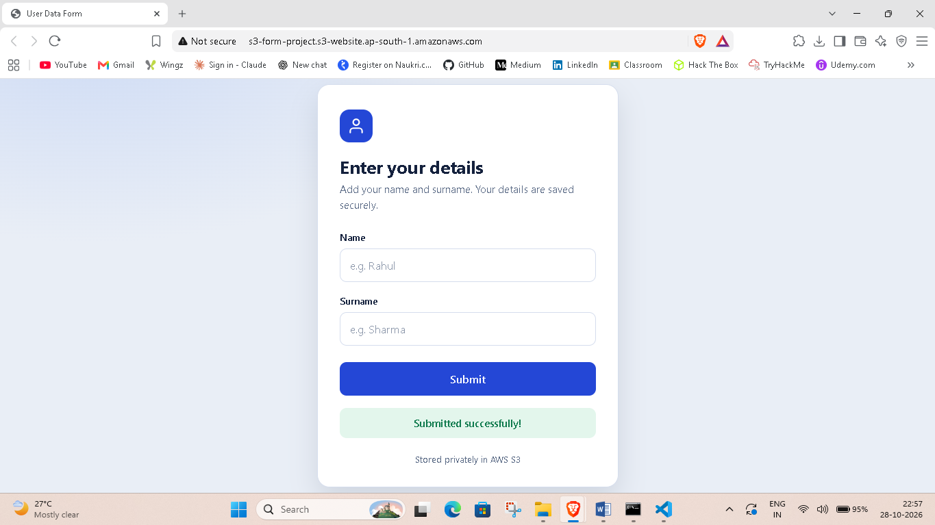

Step 14. Verify the JSON file in S3
- Go to S3 → your bucket → open the submissions/ folder.
- You will see a file like 1793208436694-ifow4heq.json.
- Click it, then Open or Download to see the data.
- Submit the form again. A new file with a different name should appear each time.
Example file content:
{ "name": "Rahul", "surname": "Sharan", "submittedAt": "2026-10-28T17:27:16.693Z" }

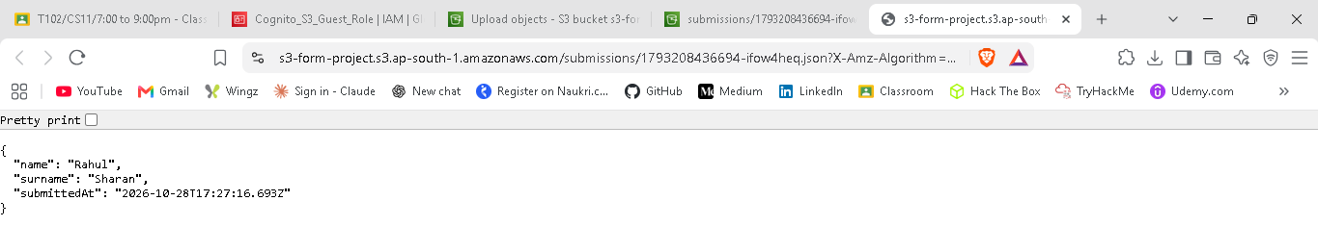

Optional privacy check: Copy the file's Object URL and open it in a new browser tab. You should see Access Denied. This proves the file is private.

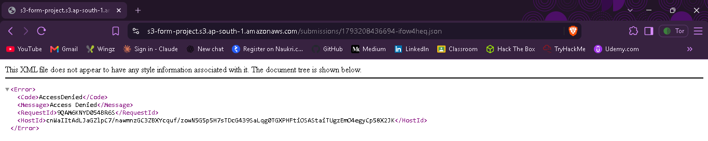

PART E: Troubleshooting
Problem | Likely cause | Fix
Error on submit, CORS message in console | CORS origin wrong | Check Step 5. Origin must match your website URL exactly (http, no trailing slash)
Access Denied on upload | IAM policy missing or wrong path | Check Step 8 bucket name and submissions/*
Cognito or credentials error | Wrong Pool ID or region | Check values in app.js, rebuild bundle, re-upload
Page shows old behavior | Forgot to rebuild or re-upload | Run esbuild again and upload new bundle.js
403 on opening website | Bucket policy or public access settings | Check Steps 2 and 4
To see the real error, press F12 in the browser and open the Console tab.

PART F: Security Checklist
- No AWS access key or secret key anywhere in the code.
- Temporary credentials come from Amazon Cognito.
- Public bucket policy covers only index.html and bundle.js.
- Submitted JSON files are not publicly readable.
- Guest role has only s3:PutObject on submissions/*.
- CORS allows only your website origin.

PART G: Deliverables
# | Deliverable | What to provide
1 | Hosted website URL | http://YOUR-BUCKET.s3-website.<region>.amazonaws.com
2 | Screenshot of working form | Browser showing the form and "Submitted successfully!"
3 | Screenshot of JSON in S3 | S3 console showing files in submissions/ (open one to show contents if possible)
4 | Screenshot of local folder | Folder showing index.html, app.js, bundle.js

Completion Criteria
The project is complete when the hosted website collects a name and surname, uploads them as a new JSON file in submissions/ on every submit, and you can see the file in the AWS Console.

